Cable Clamp Research
https://www.printables.com/model/192739-bowden-clamp-for-ctc
Screw in snap clamp, 2 halves, use screws to vary clamping force.

see “snap-in clamp” below:
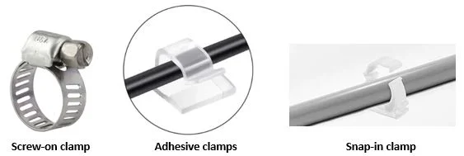
https://aerospaceer.com/bowden-cable/
Benefits are easier to put together, as the clamp can be made as part of 1 half of the segment. No need for extra print parts and fasteners.
-ves: potentially looser, or no clamping force at all dependent on design.
Examples of snap clamps
https://www.printables.com/model/196461-4mm-bowden-cable-clip/comments
Potentially just a guide, not a snap
https://www.printables.com/model/27067-locking-clothespin-clamp/files
If we build a flat base with tabs around, could work.

Misc:
https://www.westphal-gmbh.de/en/products/assembly-parts/cable-bowdencable-guides/
https://www.printables.com/search/models?q=bowden+clamp

